Assignment 3

Experiment 1 — Logistic Regression (max_iter=5)

  type: LogisticRegression

  params:

    max_iter: 5

| **Metric** | **Value** |
| --- | --- |
| Accuracy | **0.81006** |
| F1-Score | **0.80251** |

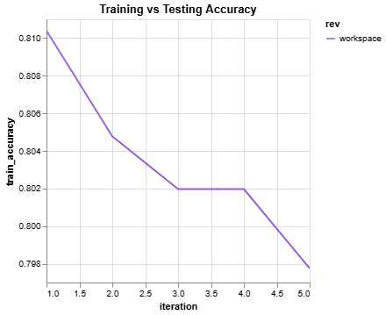

  Experiment 2 — Logistic Regression (max_iter=10)

type: LogisticRegression

  params:

    max_iter: 10

| **Metric** | **Value** |
| --- | --- |
| Accuracy | **0.80447** |
| F1-Score | **0.79623** |

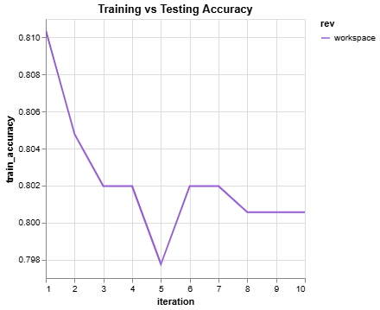

DVC Metrics Difference (compared to Experiment 1):

| **Metric** | **Previous** | **Current** | **Change** |
| --- | --- | --- | --- |
| Accuracy | 0.81006 | 0.80447 | **-0.00559** |
| F1-Score | 0.80251 | 0.79623 | **-0.00628** |
| Random Forest Experiments |  |  |  |

Experiment 3 — RandomForestClassifier (n_estimators=8, max_depth=2)

  type: RandomForestClassifier

  params:

    n_estimators: 8

    max_depth: 2

    random_state: 42

| **Metric** | **Value** |
| --- | --- |
| Accuracy | **0.78212** |
| F1-Score | **0.77184** |

Experiment 4 — RandomForestClassifier (n_estimators=16, max_depth=2)

  type: RandomForestClassifier

  params:

    n_estimators: 16

    max_depth: 2

    random_state: 42

| **Metric** | **Value** |
| --- | --- |
| Accuracy | **0.79330** |
| F1-Score | **0.78125** |
|  |  |

DVC Metrics Difference (compared to Experiment 3):

| **Metric** | **Previous** | **Current** | **Change** |
| --- | --- | --- | --- |
| Accuracy | 0.78212 | 0.79330 | **+0.01117** |
| F1-Score | 0.77184 | 0.78125 | **+0.00941** |

**Final Comparison**

| **Model Type** | **Parameters** | **Accuracy** | **F1-Score** |
| --- | --- | --- | --- |
| Logistic Regression | max_iter=5 | **0.81006** | **0.80251** |
| Logistic Regression | max_iter=10 | 0.80447 | 0.79623 |
| Random Forest | n_estimators=8 | 0.78212 | 0.77184 |
| Random Forest | n_estimators=16 | **0.79330** | **0.78125** |